**Pizza Sales SQL Queries**

**----(A) KPI'S**

**----1. Total Revenue**

**----2. Average Order Value**

**----3. Total Pizzas Sold**

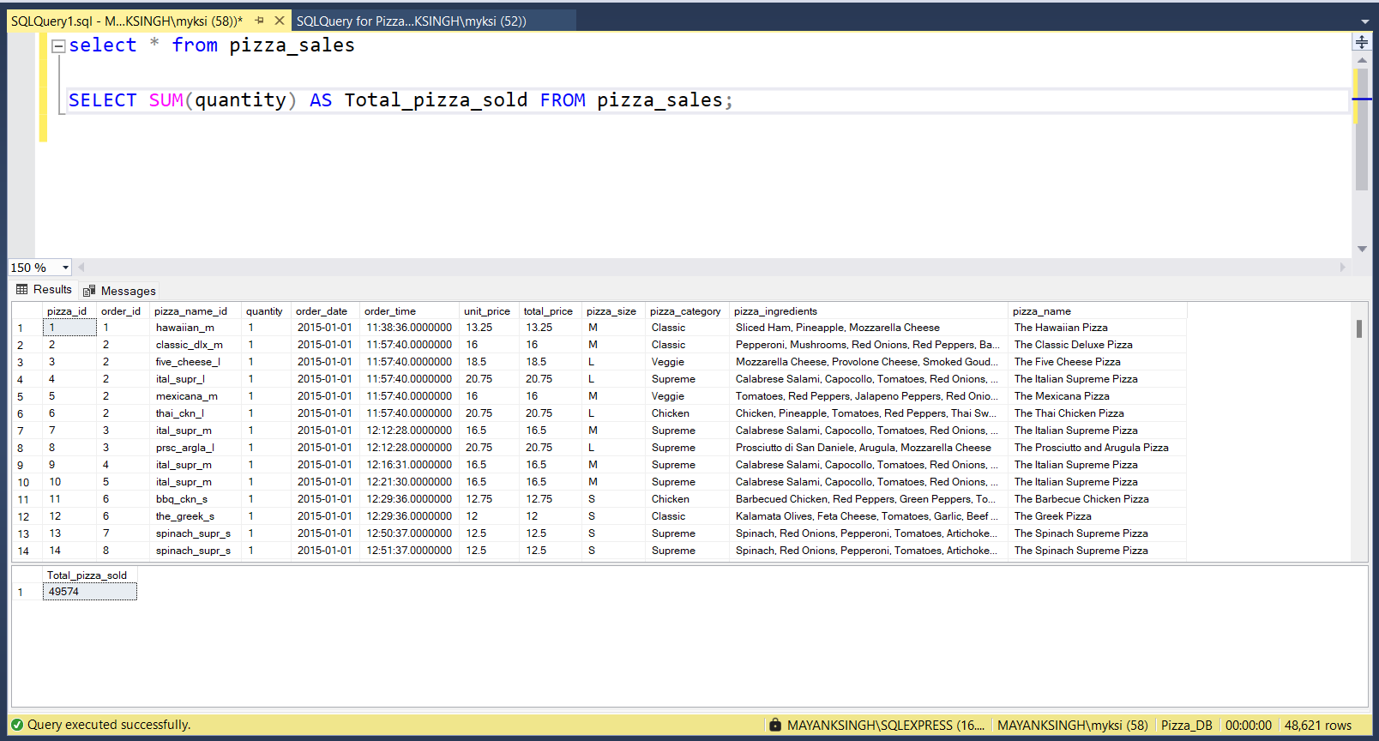

**----4. Total Orders**

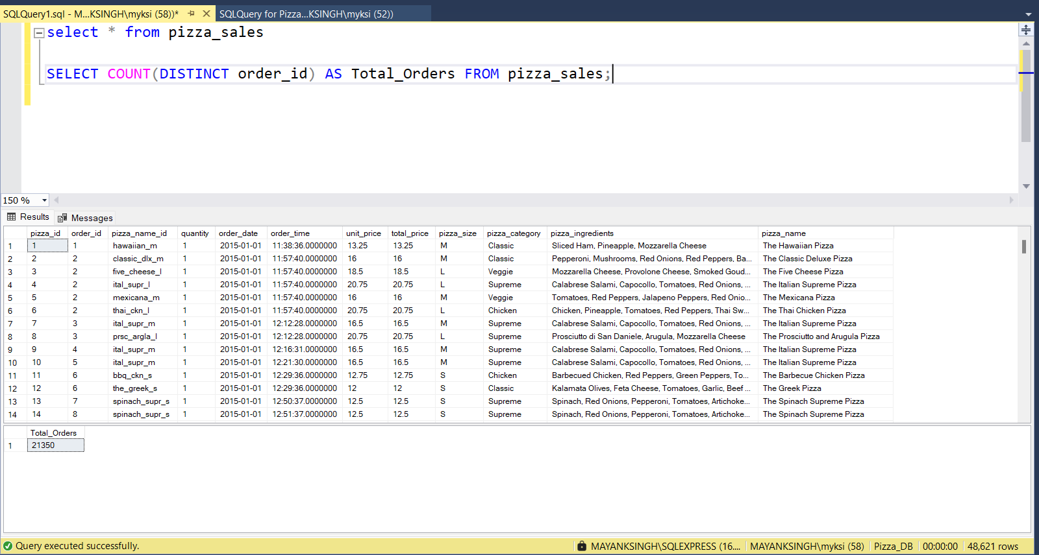

**----5. Average Pizzas Per Order**

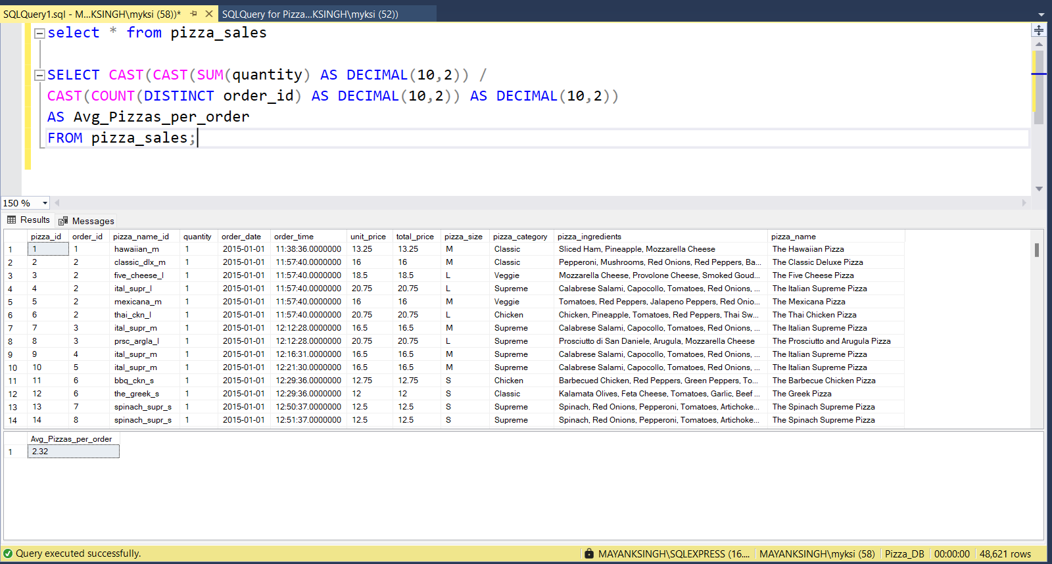

**----(B) Daily Trends for Total Orders**

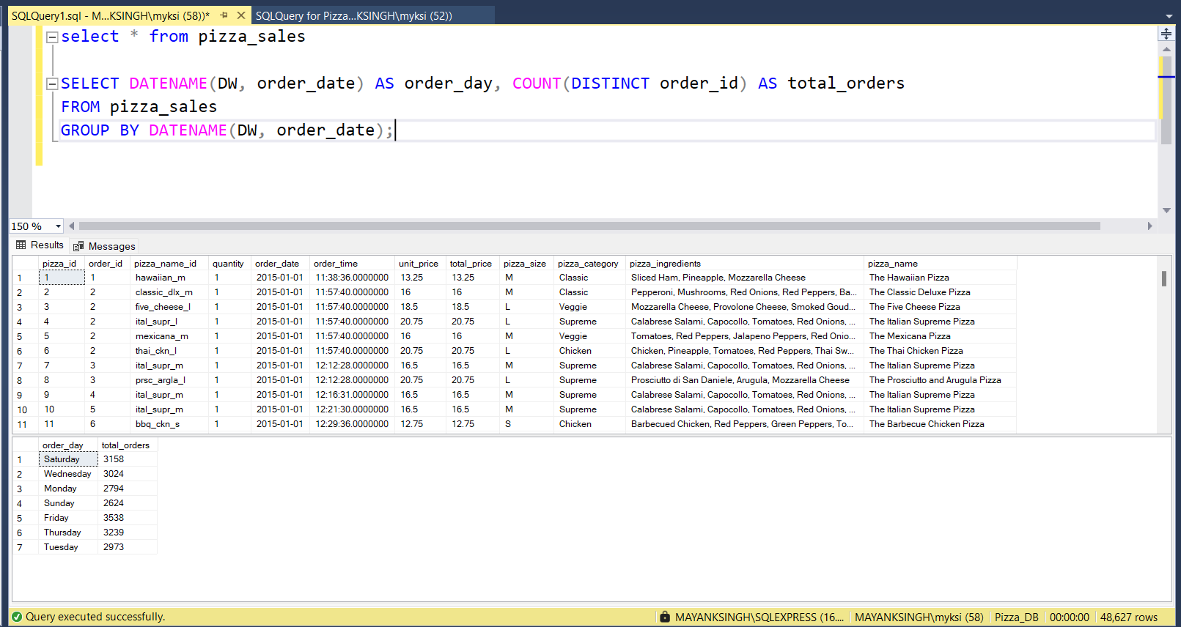

**----(C) Monthly Trend for Orders**

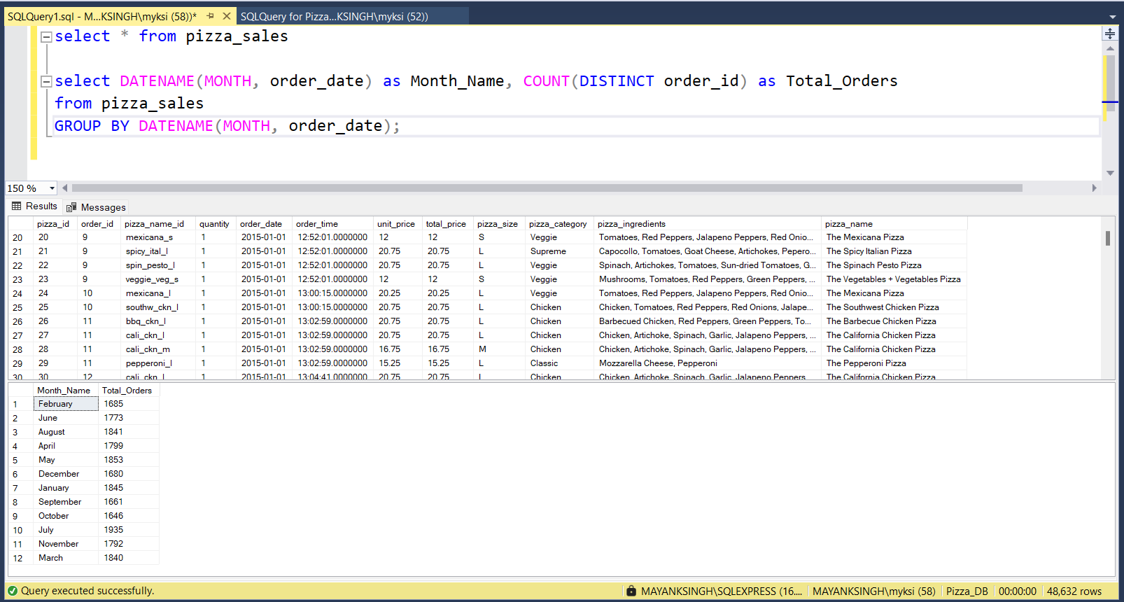

**----(D) % of Sales by Pizza Category**

**----(E) % of Sales by Pizza Size**

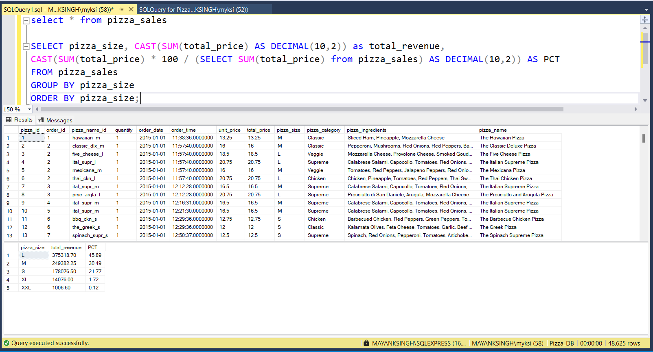

**----(F) Total Pizzas Sold by Pizza Category**

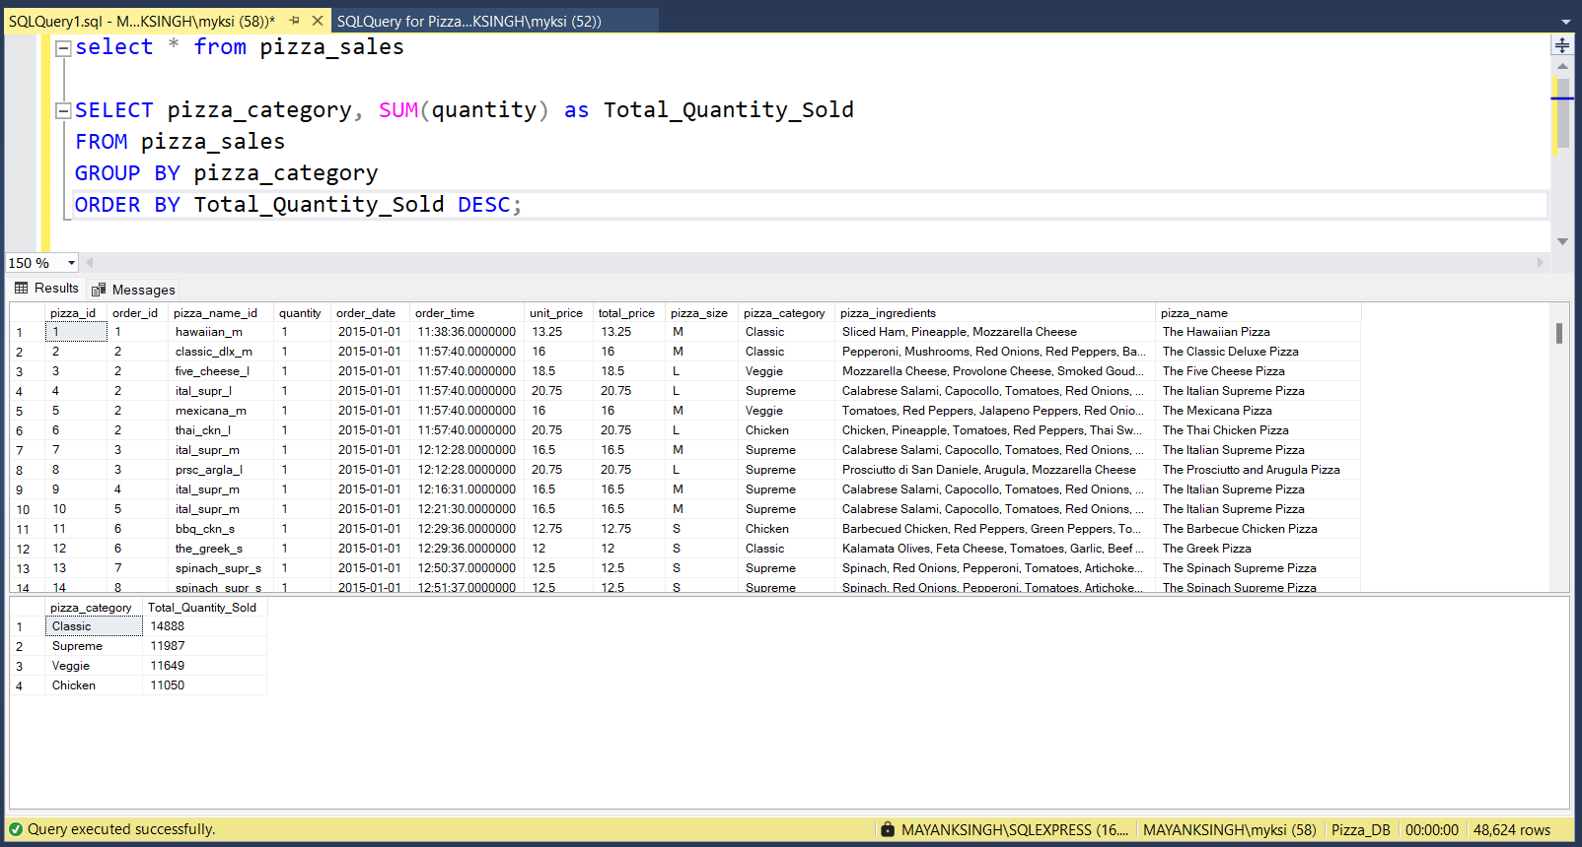

**----(G) Top 5 Pizzas by Revenue**

**----(H) Bottom 5 Pizzas by Revenue**

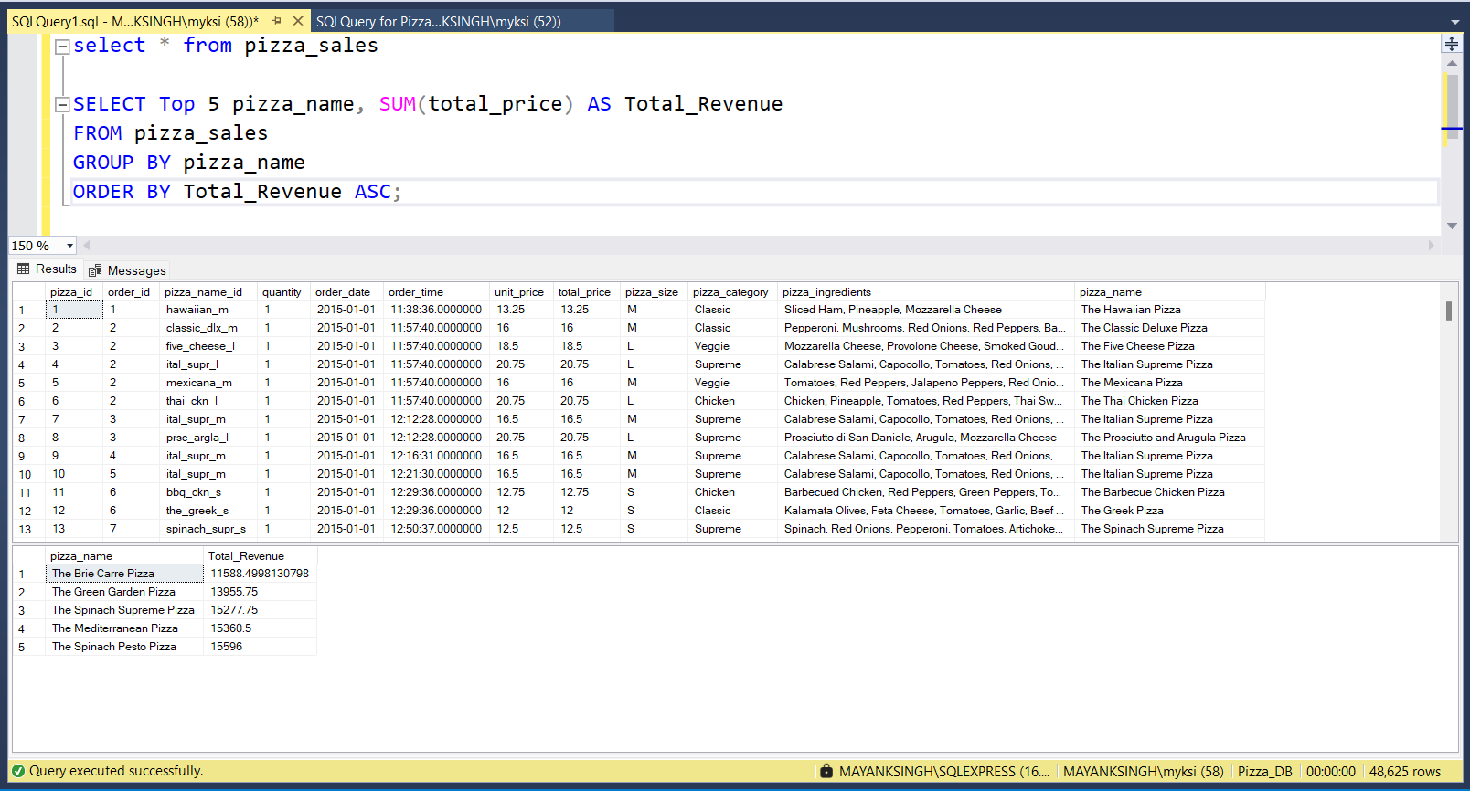

**----(I) Top 5 Pizzas by Quantity**

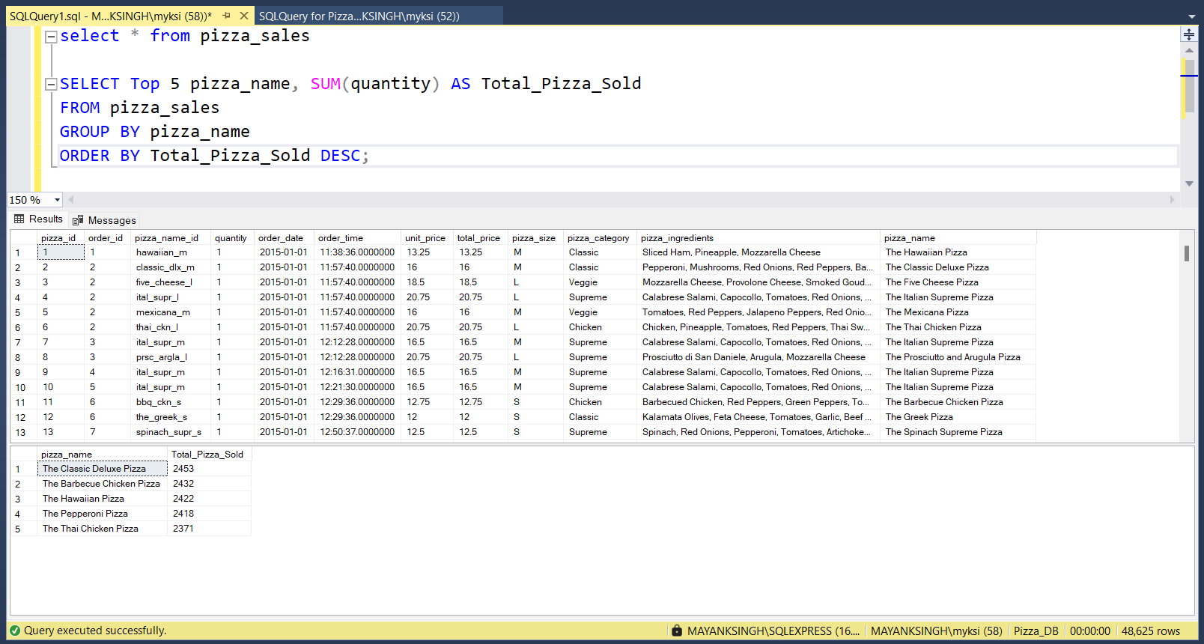

**----(J) Bottom 5 Pizzas by Quantity**

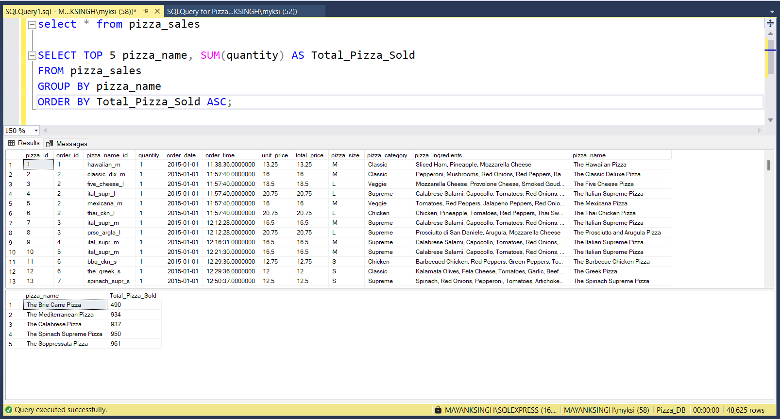

**----(K) Top 5 Pizzas by Total Orders**

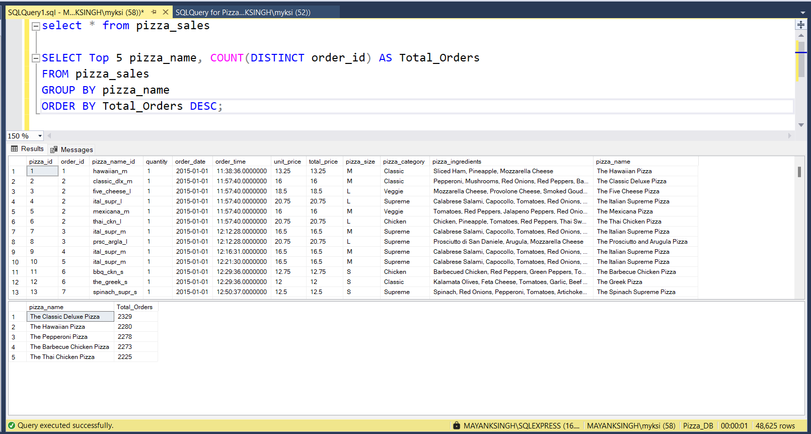

**----(L) Bottom 5 Pizzas by Total Orders**

